For our first Seaside project we will use the “Seaside One-Click Experience” in Pharo. If this tutorial came with a DVD, copy ‘Seaside-3.1-portable.app’ to your desktop and skip to step #3. Otherwise, follow steps 1 -2 to download Seaside from the web.

1. Open a web browser on [http://www.seaside.st/download/pharo/](http://www.seaside.st/) and click on the “Seaside One-Click Experience 3.1” link. This will download Seaside-3.1-portable.zip.

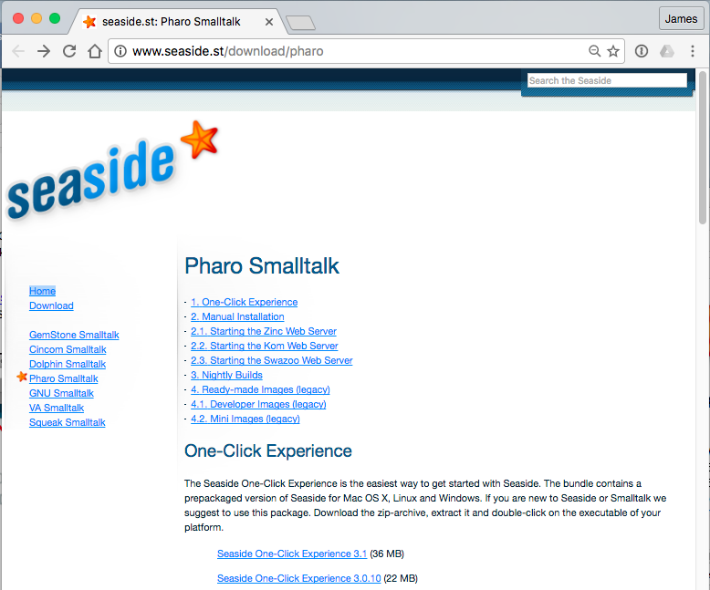

1. Locate and unzip the file (if the download process did not unzip it for you). This will create a folder named “Seaside-3.1-portable.app” that you should place in a convenient location (such as the desktop). Note that if you are on a Macintosh this “folder” will be an application package.
2. Find the executable appropriate for your operating system: Mac, Windows, or Linux. On the Macintosh, the folder will appear as a starfish icon representing an application package. On Windows, the folder can be opened to find various items, including an executable named ‘Pharo.exe’. On Linux, the folder can be opened to find various items, including ‘Pharo4.0-portable.sh’. Double click on the appropriate icon to launch the executable.

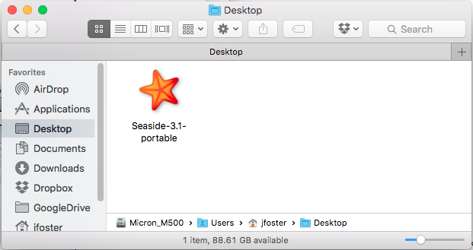

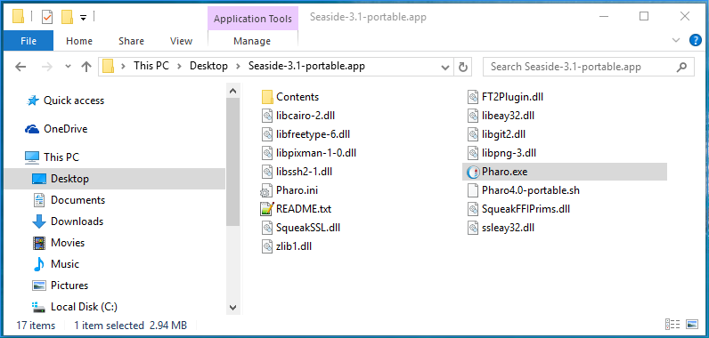

1. When you launch the executable, you are actually starting a web server in Pharo Smalltalk. As we continue through this tutorial, we will refer to this executable as “Pharo” to distinguish it from the Seaside code framework that Pharo contains. Like most Smalltalk dialects, Pharo runs as a “virtual machine” on your host operating system. You should see a new main window containing three smaller windows. This main window gives you a graphical user interface into an object space loaded into memory from the file ‘Pharo4.0-portable.image’ that was part of the earlier download. This ‘image’ is a copy of one with Seaside and a simple web server already loaded. The inner windows will be the same on all three platforms and will not look like windows created by other applications on your platform. One of the windows, labeled “Welcome to Seaside 3.1,” contains a comment telling you that a web server is already running and you can point your web browser to <http://localhost:8080/> to give it a try.

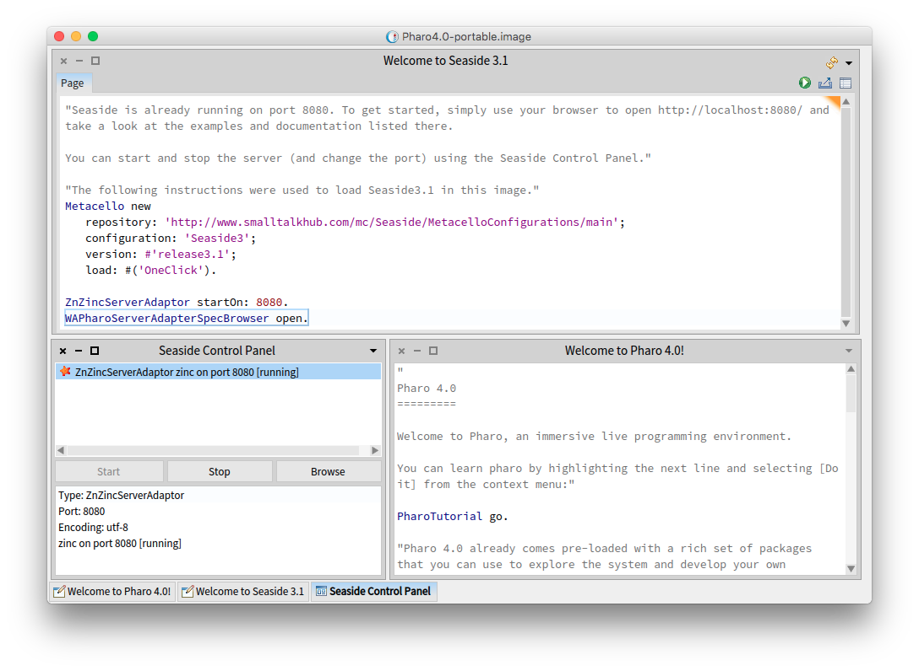

1. Open a web browser on [http://localhost:8080/](http://localhost:8080/seaside) to confirm that things are up and running correctly. You can poke around a bit here, but don’t get too distracted at this point. We’ll be exploring Seaside in more detail in Chapter 3.

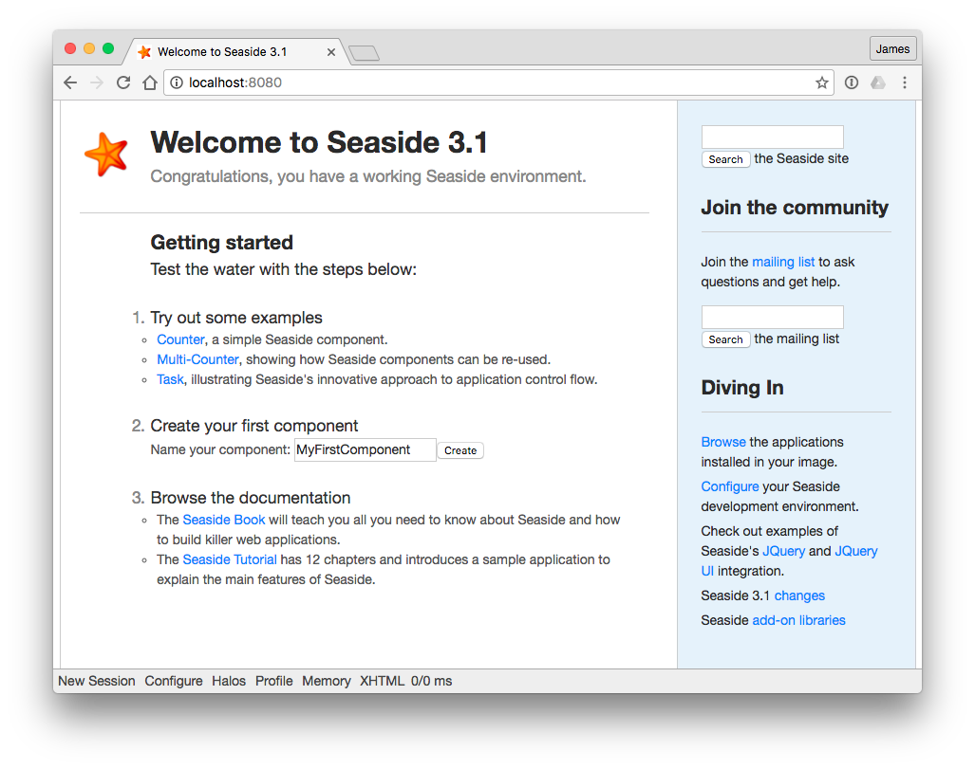

1. As we go along, we will be creating and editing code in the Pharo object space. To make the change persistent, you need to make a snapshot of the current object space—creating a new “image” (following a camera metaphor). To do this, left-click on the background (or desktop) to bring up the World menu and select ‘save’ from the menu. This will write out your changes to the default ‘Pharo4.0-portable.image’ file that will be read when you next launch the Seaside One-Click Experience.

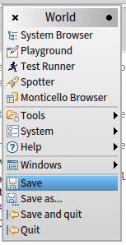

1. Smalltalkers refer to the above action as “saving the image,” and this is a handy way to preserve your changes and the environment. Think of it as a suspend action (or hibernate) for your computer. When you come back and restart your computer the same windows will be open in the same location with the same contents. If you are about to try something that might cause a problem, you could save the image before taking the risky action. Then, if things go bad you can quit without saving (see step #10 below) and simply reopen the saved image to get back to the prior state. Alternatively, you can change the name of the saved image by selecting the ‘save as…’ menu item.

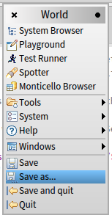

1. This will open a dialog asking for a File name for the new image. Name the new image ‘backup.image’ and click OK or press <Enter>. This gives us a ‘clean’ or ‘virgin’ image that can be restored without downloading everything again from the web or copying from a CD/DVD.

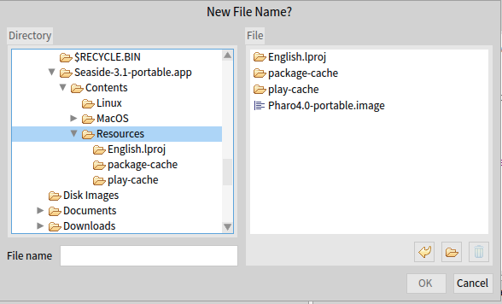

1. To see the new file, open the application folders ‘Contents’ then ‘Resources’ (on the Mac you will need to right-click on the Application icon and select ‘Show Package Contents’). If you ever want to start over, simply delete ‘Pharo4.0-portable.changes’ and ‘Pharo4.0-portable.image,’ copy ‘backup.changes’ and ‘backup.image,’ and rename the copies to ‘Pharo4.0-portable.changes’ and ‘Pharo4.0-portable.image’ (note that capitalization might be important, depending on your platform).

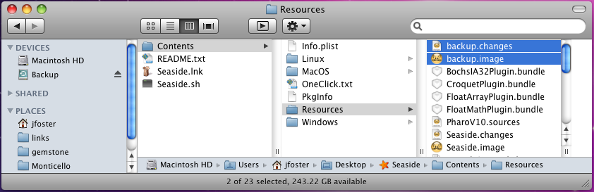

1. Now we are ready to quit the application. Left click on the background to bring up the (now familiar) World menu and select the last item, ‘quit.’ In the ‘Save changes before quitting?’ dialog, select ‘No’ to quit without saving (since we already saved two images of the current object space).

